Computer Architecture Lab
(EL-2012)
LABORATORY REPORT

Fall 2026

(Lab#5)
Use of Venus Simulator for Register Level Execution of RISC-V Control Instructions

Student Name: Huzaifa Kashif Roll No: 24I-6501 Section: CE-A

Date performed: 14th September, 2026

MARKS AWARDED: ________ / 10

Signature and date of Instructor: _________________
Lab Instructors: Dr. Nasir Ali Shah, Engr. Fasih Ahmad

______________________________________________________________________________________________________________________________________________________

NATIONAL UNIVERSITY OF COMPUTER AND EMERGING SCIENCES, ISLAMABAD
Prepared by: | Fasih Ahmad |  | Version: 1.0
Verified by: | Dr. Nasir Ali Shah |  | Updated: Fall 2026

Task 1:

Description:
beq t0, t1, target is Actual
blt t0, t1, target is Actual
ble t0, t1, target is Pseudo
bgt t0, t1, target is Pseudo
bge t0, t1, target is Actual
bne t0, t1, target is Actual

j target is Pseudo
jal ra, target is Actual
jalr zero, const(ra) is Actual

I know the difference as the pseudo instructions are shortcut instructions that can be replaced.

Task 2:

Description:
Here i tested the beq and j function. Beq would branch to test1 if x6 was equal to x5 otherwise it would
Go to test 2 due to the jumpfuction.

Code:
addi x5,x0,3
addi x6,x0,5
beq x6,x5,test1
j test2

test1:
add x5,x5,x6

test2:
addi x5,x5,1

Output:
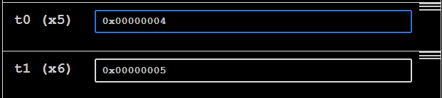

Task 3:

Description:
Code 1 :
Explanation:
Line 1: 4 is saved into save register s0.
Line 2: 6 is saved into save register s1.
Line 3: Branches to flag ‘Fin” if s0 and s1 is equal. S0 and s1 is not equal so it moves to the next line.
Line 4-5: Moves to flag ‘True’. In register s2, the result of the addition of s1 (4) and s2(6) is saved.
Line 6: j which stands for jump will jump to the flag ‘end’.
Line 9: Empty Flag. Script ends here.

Code 2:
Explanation:
Line 1: 4 is saved into save register s0.
Line 2: 4 is saved into save register s1.
Line 3: Branches to flag ‘Fin” if s0 and s1 is equal. S0 and s1 is equal so it branches to flag ‘Fin’.
Line 7-8: Moves to flag ‘True’. In register s2, the result of the addition of s1 (4) and s2(6) is saved.

Task 4:

Description:
Here i used the simple beq instruction to show the condition of the C code. It checks if a==b so i used beq.
In the case it was correct it would branch to the if block other wise it would go to the else block. Both blocks jump to the end so that the program doesnt just continue.

Code:
addi s0,x0,5 #a
addi s1,x0,10 #b
addi s2,x0,4 #d
addi s3,x0,3 #e
beq s0,s1,ifblock
elseblock:
add t0,s2,s3
j end

ifblock:
sub t0,s2,s3
j end

end:

Output:
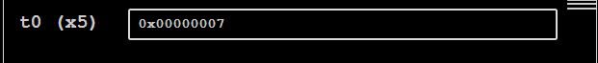

Task 5:

Description:
Here i used the slli instruction to shift two spaces to the left. Since shifting, 0010 to 1000 we go from a hex value of 0x2 to 0x8.

Code:
addi t0,x0,2
slli s0,t0,2

Output:
After First Line:
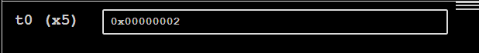
After Second Line:
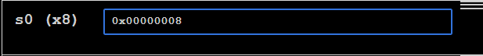

Task 6:

Description:
Here i defined t0 for the iterator and s0 for the value of n which would be constant and not change. The condition loop is checked by bge (>=). In each iteration t0 or i is incremented then it jumps back to the loop.

Code:
li t0,0 #i=0
li s0,4 #n=4

forloop:
bge t0,s0,end # if i>=n end loop by going to end
addi t0,t0,1
j forloop

end:

Output:
First Line Initilize t0 =0:
Second line set n=4 :
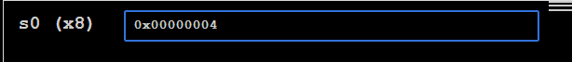

First iteration i=0:
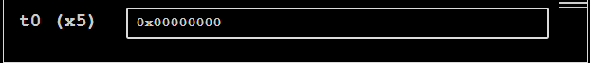
Second Iteration:
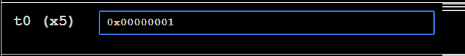
Third Iteration:
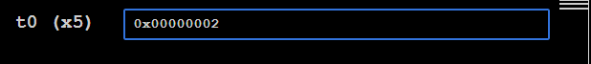
Fourth Iteration:
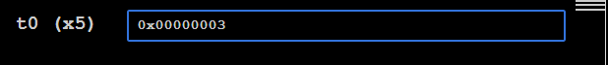
Fifth Iteration:
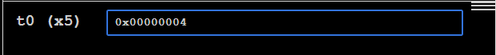

Task 7:

Description:
Here i defined an array of ten 0’s. I defined the base address with t5, n with s0 and iterator i with t0. The loop checks the condition first using bge(>=) and it is iterated. It sotres the value of i+5 in t1. Then an offset of the base address is stores in t5. This is where i+5 is stored into. Then i is incremented.

Code:
.data
num: .word 0, 0, 0, 0, 0, 0, 0, 0, 0, 0

.text
addi t0,x0,0 #i
li s0,5 #n
la t5,num #base address

whileloop:
bge t0,s0,end
addi t1,t0,5 # i+5
sw t1,0(t5) # num[i] = i+5

addi t5,t5,4 #4 offset
addi t0,t0,1 #i++

j whileloop

end:

Output:
Setting i =0
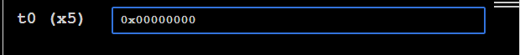
Setting n = 5
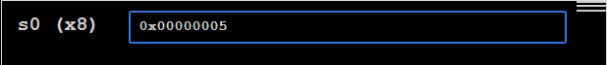
i=0 — num[0] = 0+5
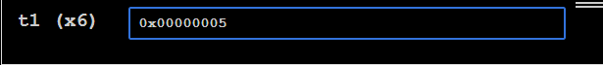
i=1 — num[1] = 1+5

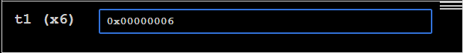

i=2 — num[2] = 2+5

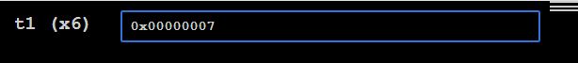
i=3 — num[3] = 3+5
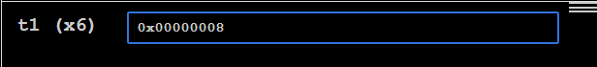
i=4 — num[4] = 4+5

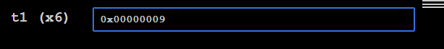

Task 8:

Description:
Here i defined each x and y with t1 and t2. These will be iterators and nx and ny which will be constant.
A counter is defined at t0 to store the results. Two flags, for x loop which is the outer loop and for y loop which is the inner loop.

Code:
addi t0,x0,0 #counter
addi t1,x0,0 # x
addi t2,x0,0 # y
addi s0,x0,3 #nx
addi s1,x0,2 #ny

forxloop:
bge t1, s0, end #exit
addi t2, x0, 0

foryloop:
bge t2, s1, nextx
add t0, t1, t2
addi t2, t2, 1
j foryloop

nextx:
addi t1, t1, 1
j forxloop

end:

Output:
Counter,x,y,nx,ny Initalized:
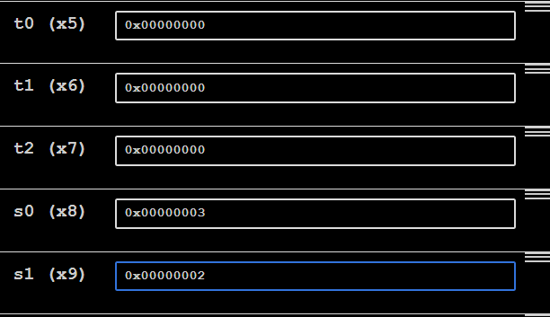
Counter value :
